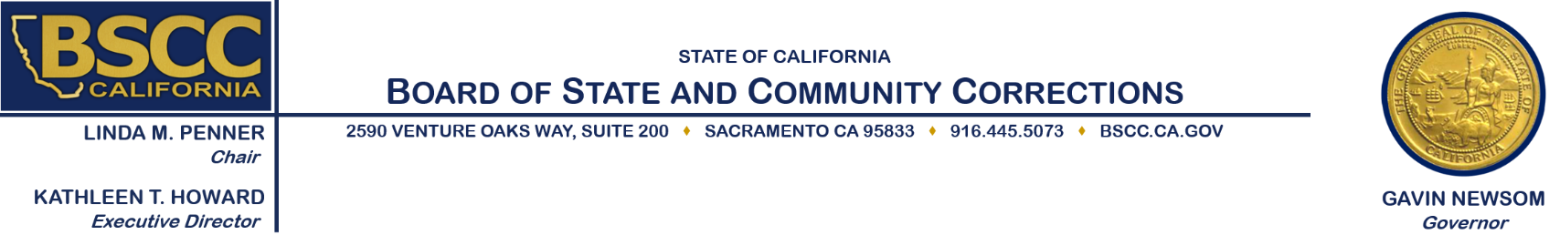

2019 Youth Reinvestment Grant
Executive Steering Committee Meeting
Thursday, September 19, 2019
9:30 a.m.

Meeting Location:
Board of State and Community Corrections
BSCC Board Room – 1st Floor
2590 Venture Oaks Way
Sacramento, CA 95833

Agenda Items

- Welcome and Introductions

- Present the Day’s work plan

- Review the Youth Reinvestment Grant (YRG) Legislation from 2018 & 2019

- Brief overview of the Request for Proposals for Cohort 1

Working Lunch

- Discuss and Decide on Necessary Changes to the RFP for 2019 YRG

- Public Comment

- Adjourn

Note: Agenda items may be taken out of order.

Meeting Contact Information:
Please contact Field Representative Kimberly Bushard at (916) 324-0999 or kimberly.bushard@bscc.ca.gov for additional information about this notice, to submit written material regarding an agenda item or to request special accommodations for persons with disabilities. This agenda and additional information about the Board of State and Community Corrections may be found on our website at www.bscc.ca.gov.

