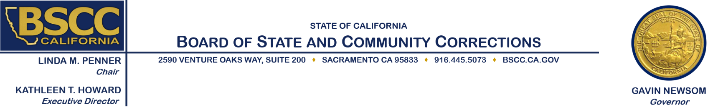

2019 Youth Reinvestment Grant
Executive Steering Committee Meeting
Wednesday, September 18, 2019
1:30 p.m.

Meeting Location:
Board of State and Community Corrections
BSCC Board Room – 1st Floor
2590 Venture Oaks Way
Sacramento, CA 95833

Agenda Items

- Welcome and Introductions

- Overview of the BSCC

- Review of Executive Steering Committee Process, Roles & Responsibilities
- Introduction to the Youth Reinvestment Grant Legislation from 2018 & 2019

- Discuss the Request for Proposals and Process used for Cohort 1

- Present the general work plan for Day 2

- Public Comment

- Adjourn

Note: Agenda items may be taken out of order.

Meeting Contact Information:

Please contact Field Representative Kimberly Bushard at (916) 324-0999 or kimberly.bushard@bscc.ca.gov for additional information about this notice, to submit written material regarding an agenda item or to request special accommodations for persons with disabilities. This agenda and additional information about the Board of State and Community Corrections may be found on our website at www.bscc.ca.gov.

